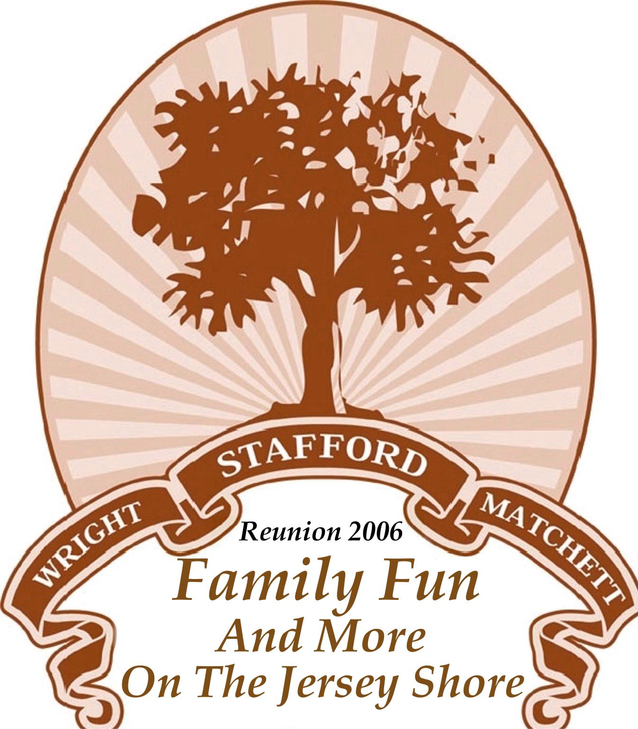

Stafford 7-Generation Genealogy
Leah Stafford married Sam Wright.  To this union, the children known are as follows:  Arnette Wright  Irene Wright Matchett  Rosa Wright Williams  Judessa Wright Woods  Rachal Wright Jenrette  Sammie Wright  Maude Wright Jones  Lacie Wright  Chauncey Wright  Leah Wright Paige  Clearice Stafford married Morris Wright, Sr., their children were:  Henry Wright  Morris Wright, Jr.  George Wright  Lewis Wright  Henry Stafford married Eliza Matchett, their children were:  Ceola Stafford Bryant  (Later Tom Bryant married Cornelius McMillan Bryant)  Rosie Stafford Morgan  William H. Stafford  Ida Stafford Williams  Samuel L. Stafford  Wesley Stafford  Thomas Stafford  Mayo Stafford Sample  Samuel Stafford, son of Peyton and Rosette, died at an early age.  He had no descendants.  At present there are seven generations from the union of Henry (Peyton) and Rosette Stafford. | The Matchett and Stafford families were united as follows:  Joe Jenkins married Eliza Butler. Their children were:  Sylvia Jenkins  Coaster Jenkins  Joseph Brown Jenkins  Sylvia married Wesley Matchett. Their children were:  Eliza Matchett Stafford  Pearl Matchett Gilliard  Rosa Matchett Brinkley  Joseph Matchett  Henry Matchett  Pearl married Reverend Gilliard. To this union the following children were born:  Pearl Cilliard Boston  Ellen D. Gilliard Glass  Sarah Gilliard Jaudon  Willie Gilliard Small  Thomas Gilliard  Doretha Gilliard Moody  Joseph Matchett married Henrietta Howell. Their children were:  QUEEN ESTER MATCHETT (added 1-10-06)  Ethel Matchett Rountree  Florence Matchett Miller  Joseph Matchett, Jr.  Eliza Matchett married Henry Stafford.  Rosa Matchett married William Brinkley, Their Children were:  Wesley Brinkley  Pearl Brinkley Lissimore  Otis Brinkley  Eliza Brinkley Williams  Roxie Brinkley Griggler  Mattie Brinkley

