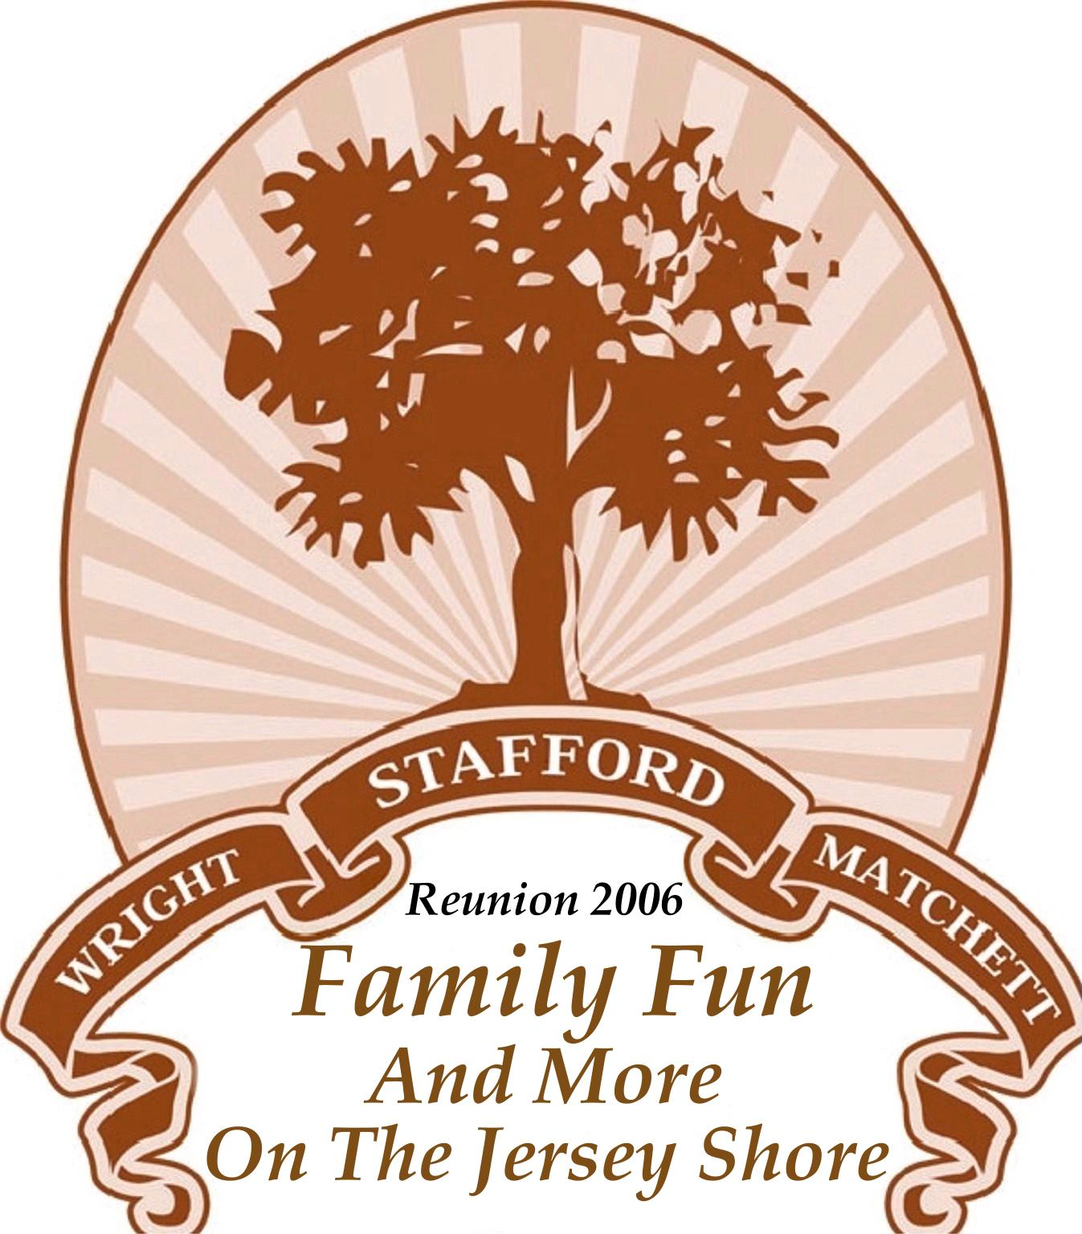

A Short History of Peyton and Rosette Stafford

The following account of our family’s history has been gathered in
bits from older members of our family, most of whom are deceased.
Henry Shanks, nicknamed “Peyton”, a slave, was born in 1830 in the state of Virginia. He died in 1932 at the age of 102.
Peyton left Virginia at the age of 12 and came to Georgia. During his youth, he cared for a master whose last name was Stafford. He was later married to Rosetta and to this union five children, to our knowledge, were born:
Leah Stafford
Clearice Stafford
Henry Stafford, Jr.
Samuel Stafford
George Stafford
The youngest child, George was born approximately one year after slaves were freed.
Peyton Stafford contributions as recalled by Caesar Stafford,
the youngest grandchild living:
He was very talented with crafts. He made sage baskets (broom-straw) of all sizes, shapes and various designs. He placed hickory into handles so as to reinforce.
These baskets were a delight to carry because they were very neat and well made. Sizes ranged from shopping baskets half bushel, one bushel and larger — he also made fancy brooms. Both items were sold to many, many customers, but to his offspring, these were a gift. Each family group owned one of his bushel baskets.
Caesar Stafford also recalls his strong constitution after his 100th birthday; Caesar was plowing with a mule. Grandpa Peyton took the plow and plowed a spell. This incident is an unforgettable one and is a challenge to those of us who seem to give up at even age 65 or younger.

